**Methodology**

The data collection will focus on 10 years’ timeline from 2011 to 2020 focusing on the UK market index in the London Stock Exchange (LSE) comparing with the data on the UK EPU index and the trading volume in the LSE. The data collection will be on secondary data approach where the data is obtained through the available primary data through public website including Yahoo Finance for London Stock Exchange (LSE) index, Global EPU Index platform for UK EPU index and financial website for investor sentiment. In addition, in order to control the potential impact of various macro indicators on the model, using the Consumer Price Index (CPI), and Treasury bond yield ($R_{f}$) as control variables.

**Data Obtaining and Preprocessing**

We use the consumer confidence index (CCI) of the United Kingdom (<https://data.oecd.org/leadind/consumer-confidence-index-cci.htm>) as a measure of investor sentiment based on previous studies. Based on responses to questions about their anticipated financial condition, their sentiment about the general economic situation, unemployment, and savings capability, the consumer trust indicator predicts future trends in household consumption and saving. An indicator above 100 indicates that consumers are more optimistic about the potential economic situation, and as a result, they are less likely to save and more likely to spend money on big purchases in the coming year. Indicator below 100 reflect a negative outlook on potential economic developments, likely leading to a desire to save more and spend less.

Meanwhile, the official website (<http://www.policyuncertainty.com>) will be used to collect the EPU index. The index is focused on articles in newspapers about policy uncertainty. The Times, The FT, The Telegraph, Sunday Times, The Guardian, The Daily Mail, The Mirror, The Daily Express, The Sun, The Evening Standard, and The Northern Echo are among the 11 UK newspapers represented. The phrases uncertainty, economic or market, and policy related terms are used in the news articles. ' tax,' ' regulation,"spending,"policy,' are words that are applicable to policy.

The FTSE 100 index (<https://www.londonstockexchange.com/indices/ftse-100>) is an index of the 100 largest companies listed on the London Stock Exchange as the representative of the return of stock market in UK. The index is a barometer of the British economy and one of the most important stock indexes in Europe. The return of stock market is measured by the increase or decrease of the index in a monthly period.

As for the collection of control variables, CPI index will be collected as one of them, a macroeconomic indicator that reflects changes in the price level of consumer goods and services generally purchased by households, to represent the influence of social economic influencing factor to stock return. Besides, according to the Capital Asset Pricing Model (CAPM), relationship exerts between systematic risk and expected return for assets, and this is particularly common when it comes to the measurement for the return of stocks. Therefore, the return of a risk-free bond (systematic risk) should also be considered as a control variable and I obtain the annual yield of the UK treasury bond to act as the systematic risk in the research.

The regression test will be including in the research methodology as this is crucial in explaining the phenomena of the significant relationship of the independent variable in EPU index and investor sentiment against the dependent variable in the market return (Demir & Ersan, 2018). The stepwise regression model will be used to predict the value of the dependent variable and estimate the effect of some explanatory variable on the dependent variable. The proposed research methodology will emphasize on the use of Rstudio software in generating the statistical data that will help in interpretation and hypothesis testing to draw the finding for this research.

**Regression Model**

The establishment of the regression model will refer to the research of Rehman and Apergis (2019).

$R_{t}=β_{0}+ β_{1}CCI+β_{2}EPU+β_{3}CPI+β_{4}R_{f}+ε$.

(Rehman and Apergis, 2019)

$R_{t}$*refers to the monthly return rate of the FTSE 100 index; CCI refers to consumer confidence index (investor sentiment); EPU refers to economic policy uncertainty; CPI refers to Consumer Price Index and $R_{f}$ refers to* *Treasury bond yield.*

**Hypothesis Testing**

This research will cover the 3 hypotheses:

*H1: There is significant relationship between EPU and the return of stock market*

*H2: There is significant relationship between investor sentiment and return on stock market*

*H3: There is a positive correlation between EPU, investor sentiment and return of stock market*

Dependent Variable

Independent Variable

Economy Policy Uncertainty Index

Return on stock market

Investor Sentiment

**Data Analysis**

**Descriptive Analysis**

According to the descriptive statistics below. We can see that EPU went through tremendous fluctuation during the ten years, with 0.31 as the standard deviation of its growth rate, while the zero mean of the CCI growth rate tells that CCI goes up and down slightly around its mean, almost remain at a certain level during the ten years. Similar to CCI, CPI also performs a relative steady distribution among the ten years.

**Table 1 Descriptive Statistics**

|  |  |  |  |  |  |  |
| --- | --- | --- | --- | --- | --- | --- |
| Variable | Min | Max | Mean | Std | 1th Qu | 3rd Qu |
| $$EPU$$ | 78.138% | 112.517% | 82.16% | 76.384% | 81.461% | 92.494% |
| $$CPI$$ | -22.568% | 1.016% | -0.030% | 2.099% | 0.01% | 0.38% |
| $$CCI$$ | 1.85% | 2.13% | 2.07% | 0.0864% | 1.93% | 2.08% |
| $$R_{f}$$ | -13.808% | 12.352% | 0.143% | 3.675% | 31.68% | 57.4% |
| $$R_{t}$$ | 3.75% | 89.48% | 46.35% | 27.09% | 20.65% | 67.78% |

**EPU:整体偏大，平均值比最小值大，**

**Return：平均回报0.46，**

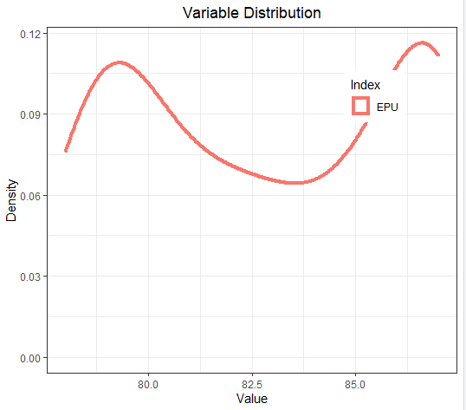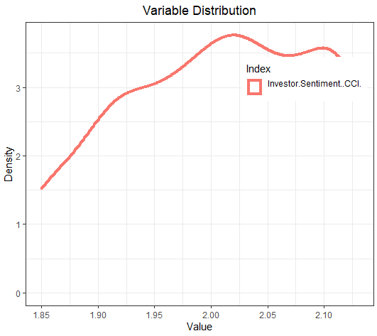

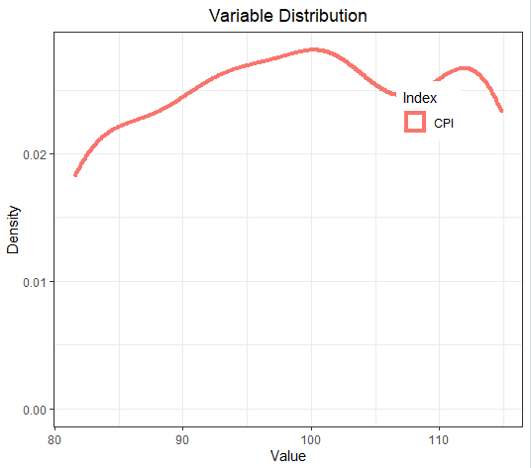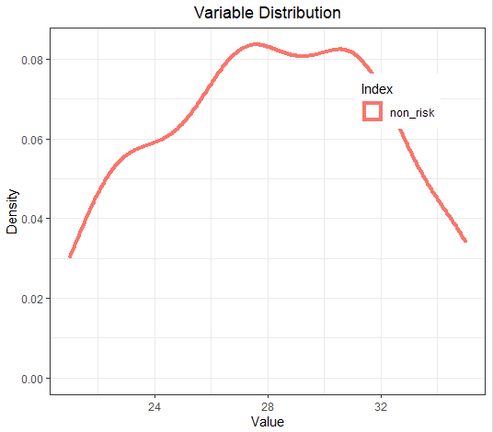

Figure 1 Density plot

平均值比中位数小，According to the plot of the density distribution of EPU and EPU growth rate, as shown in Fig1, it shows that both EPU and EPU growth rate show a right-skewed distribution, that is, the average is larger than the median. The skewness coefficient is larger than 0, which is also called positive skewed.

平均值比中位数（Median）大，According to the plot of the density distribution of EPU and EPU growth rate, as shown in Fig1, it shows that both EPU and EPU growth rate show a right-skewed distribution, that is, the average is larger than the median. The skewness coefficient is less than 0, which is also called negative skewed.

平均值比中位数（Median）大，According to the plot of the density distribution of EPU and EPU growth rate, as shown in Fig1, it shows that both EPU and EPU growth rate show a right-skewed distribution, that is, the average is larger than the median. The skewness coefficient is less than 0, which is also called negative skewed.

平均值比中位数（Median）小，According to the plot of the density distribution of EPU and EPU growth rate, as shown in Fig1, it shows that both EPU and EPU growth rate show a right-skewed distribution, that is, the average is larger than the median. The skewness coefficient is larger than 0, which is also called positive skewed.

Then is about the return rate for both stocks among years. Fig 3 tells that among years, the return of the FTSE 100 index fluctuates slightly around 0. However, the annual yield of the UK treasury bond behaves the opposite.

Figure 3 Return Rate of two Capital Assets

**Unit Root Test**

|  |  |  |  |  |
| --- | --- | --- | --- | --- |
|  | EPU | CCI | CPI | $$R_{f}$$ |
| **ADF (1st difference)** | -3.2282 | -0.2992 | -0.613 | -0.5693 |
| **PP (level)** | 0.2145 | 0.6109 | 0.544 | 0.5529 |
| **PP (1st difference)** | 0.001438 | 0.5761 | 0.4499 | 0.4687 |

**Regression Model Analysis**

|  |  |  |  |  |
| --- | --- | --- | --- | --- |
|  | Estimate | Std. Error | **t value** | **Pr(>|t|)** |
| (Intercept) | -4.722845 | 0.733061 | -6.443 | 2.78e-09 |
| EPU | 0.042667 | 0.005339 | 7.992 | 1.09e-12 |
| CCI | 0.631954 | 0.342929 | 1.843 | 0.0679 |
| CPI | -0.005706 | 0.002660 | -2.145 | 0.0340 |
| $$R_{f}$$ | 0.032966 | 0.004595 | 7.175 | 7.34e-11 |

**Model Statistics**

|  |  |
| --- | --- |
| Residual standard error | 0.191 on 116 degrees of freedom |
| Multiple R-squared | 0.5197 |
| Adjusted R-squared | 0.5032 |
| F-statistic | 31.38 on 4 and 116 DF |
| p-value | < 2.2e-16 |

**Pearson**

|  |  |  |  |
| --- | --- | --- | --- |
|  | t | p-value | Correlation |
| EPU | 7.0954 | 1.004e-10 | 0.5452451 |
| CCI | -1.039 | 0.3009 | -0.094814 |
| CPI | -0.68989 | 0.4916 | -0.06311563 |
| $$R_{f}$$ | 6.3202 | 4.719e-09 | 0.5013136 |

|  |  |  |  |  |  |
| --- | --- | --- | --- | --- | --- |
|  |  | EPU | CCI | CPI | $$R_{f}$$ |
| $$R_{t}$$ | 1 | 0.54524513 | -0.09481488 | -0.06311563 | 0.50131358 |
| EPU | 0.54524513 | 1 | -0.04781042 | 0.05956421 | 0.09650454 |
| CCI | -0.09481488 | -0.04781042 | 1 | 0.79072931 | -0.18550843 |
| CPI | -0.06311563 | 0.05956421 | 0.79072931 | 1 | -0.04696916 |
| $$R_{f}$$ | 0.50131358 | 0.09650454 | -0.18550843 | -0.04696916 | 1 |

**下面是需要根据上面的数据和内容改**

**Testing of Hypothesis 1**

Here, we carry out linear regression among the Economic Policy Uncertainty factor and return on stock market, and test whether Hypothesis 1 - *There is significant relationship between EPU and the return of stock market* – is true.

According to previous studies, we build the following models to test their relationships.

$R_{t}=β_{0}+β_{1}{EPU}_{t}+ε .$ (1)

$R_{t}=β_{0}+β_{1}{EPU}_{t}+β_{2}{CPI}_{t}+ε .$ (2)

$R_{t}=β_{0}+β_{1}{EPU}_{t}+β_{2}R_{f}+ε .$ (3)

$R_{t}=β_{0}+β_{1}{EPU}_{t}+β_{2}{CPI}_{t}+β_{3}R_{f}+ε .$ (4)

$R_{t}=β_{0}+β_{1}{EPU_G}_{t}+ε .$ (5)

$R_{t}=β_{0}+β_{1}{EPU_G}_{t}+β_{2}{CPI_G}_{t}+ε .$ (6)

$R_{t}=β_{0}+β_{1}{EPU_G}_{t}+β_{2}R_{f}+ε .$ (7)

$R_{t}=β_{0}+β_{1}{EPU_G}_{t}+β_{2}{CPI_G}_{t}+β_{3}R_{f}+ε .$ (8)

$R_{t}$ acts as the monthly return rate of the FTSE 100 index, and $R_{f}$, representing the annual yield of the UK treasury bond, is one of the control variables for stock return. ${EPU}_{t}$ is the policy uncertainty index while ${EPU_G}_{t}$ is the growth rate of the EPU in the corresponding consecutive months. ${CPI}_{t}$ is the consumer price index, acting as another control variable for stock return, while ${CPI_G}_{t}$ is the growth rate of the CPI in the corresponding consecutive months.

Model (1) tests the impact of economic policy uncertainty on stock return, while model (2) and model (3) separately add the impact of CPI and the systematic risk in. Model (4) adds them in together. Since return rate is a growth factor for stock prices, we add other growth factors to the model. Therefore, model (5) tests the effect of economic policy uncertainty growth rate on current stock return, while model (6) and model (7) separately add the impact of CPI growth rate and the systematic risk in. Same as above, model (8) adds them in together.

Before we carry out our bivariate regression, we first utilize correlation-test on the variables by using R programming, Pearson statistics are computed for continuous variables.

**Table 2 Pearson Statistics**

|  |  |
| --- | --- |
| Variables | Pearson |
| $R_{t}$ and ${EPU}_{t}$ | 0.042 |
| $R_{t}$ and ${EPU_G}_{t}$ | -0.205** |

Table 2 Pearson Statistics

**Note: ***, **, and * indicate passing the 1%, 5% and 10% significance test respectively.**

It can be seen that $R_{t}$ and ${EPU}_{t}$ do not passed the correlation coefficient test, indicating that correlation does not exists between them. Also, the p-value of the Anova-test of the regression model (1) is much larger than 0.05, indicating that the regression equation is not statistically significant, that is, there is no linear relationship between the independent and dependent variables at the 5% significant level. Apart from ${EPU}_{t}$, there are only control variables in model (2), (3) and (4). However, control variables are also called non-experimental variables, that is to say, we should not consider the model if there do not exists correlation between the independent variable and the dependent variable. Therefore, we do not need to fit model (2), (3) and (4) in.

$R_{t}$ and ${EPU_G}_{t}$ passed the correlation coefficient significance test at the 5% significance level, which means that the correlation between return rate and economic policy uncertainty growth rate is significant. Results of regression analysis generated by R programming for other models are shown below.

**Table 3 Regression Results**

|  |  |  |  |  |
| --- | --- | --- | --- | --- |
| Variable | Model 5 | Model 6 | Model 7 | Model 8 |
| $${EPU_G}_{t}$$ | -0.0240** | -0.0237** | -0.0238** | -0.0233** |
| $${CPI_G}_{t}$$ |  | 0.0271 |  | 0.0350 |
| $$R_{f}$$ |  |  | -0.0208 | -0.0210 |
| Intercept | 0.0025 | 0.0026 | 0.0113 | 0.0113 |

Table 3 Regression Results

**Note: ***, **, and * indicate passing the 1%, 5% and 10% significance test respectively.**

Clearly, there exist significantly direct relationship between the growth rate of EPU and the return rate of the FTSE 100 index, and the following plot also tells clear correlation between $R_{t}$ and ${EPU_G}_{t}$. Therefore, hypothesis 1 is true.

Figure 3 Regression of Model 5

After fitting, I plot the residuals and carry out Box-test to test the independency of residuals. From the plot, I can spot out that the residual is basically unrelated to the estimated value and the Box test obtain a p-value larger than 0.05, meaning the residuals pass the test, thus no serial correlation exists among residuals, information has been fully extracted. Also, I draw a normal QQ-plot of the residuals to detect whether the residuals are normally distributed (a basic assumption of the linear regression). The plot tells that the residuals follow a basic normal distribution of residuals, meets the assumption that error term is a random variable subject to normal distribution and independent of each other.

Figure 4 Residuals of Model 5

Figure 5 QQ-Plot of Residuals of Model 5

Till now, the model passes the test, thus, does not need to be modified. For hypothesis 1, negative correlation exists between the two variables. EPU growth rate is a negative index (the larger the value of the index, the worse it behaves), indicating that actually, the correlation is positive between certainty and monthly return rate of the FTSE 100 index. More specifically, when EPU meets a decrease of 1%, the monthly return rate of the FTSE 100 index rises by 0.024%.

**Testing of Hypothesis 2**

Here, we carry out linear regression among the sentimental factor and return on stock market, and test whether Hypothesis 2 *-There is significant relationship between investor sentiment and return on stock market –* is true.

According to previous studies, we build the following models to test their relationships.

$R_{t}=β_{0}+β_{1}{CCI}_{t}+ε .$ (9)

$R_{t}=β_{0}+β_{1}{CCI}_{t}+β_{2}{CPI}_{t}+ε .$ (10)

$R_{t}=β_{0}+β_{1}{CCI}_{t}+β_{2}R_{f}+ε .$ (11)

$R_{t}=β_{0}+β_{1}{CCI}_{t}+β_{2}{CPI}_{t}+β_{3}R_{f}+ε .$ (12)

$R_{t}=β_{0}+β_{1}{CCI_G}_{t}+ε .$ (13)

$R_{t}=β_{0}+β_{1}{CCI_G}_{t}+β_{2}{CPI_G}_{t}+ε .$ (14)

$R_{t}=β_{0}+β_{1}{CCI_G}_{t}+β_{2}R_{f}+ε .$ (15)

$R_{t}=β_{0}+β_{1}{CCI_G}_{t}+β_{2}{CPI}_{t}+β_{3}R_{f}+ε .$ (16)

$R_{t}$ acts as the monthly return rate of the FTSE 100 index, and $R_{f}$, representing the annual yield of the UK treasury bond, is one of the control variables for stock return. ${CCI}_{t}$ is the consumer confidence index, while ${CCI_G}_{t}$ is the growth rate of the CCI of the corresponding consecutive months. ${CPI}_{t}$ is the consumer price index, acting as another control variable for stock return, while ${CPI_G}_{t}$ is the growth rate of the CPI in the corresponding consecutive months. Model (9) tests the impact of consumer confidence on stock return and model (13) changes the measure of consumer confidence by using CCI growth rate. Other models add control variables in.

Similarly, we carry out correlation-test on the variables before we apply regression to our model, Pearson statistics are computed for continuous variables.

|  |  |
| --- | --- |
| Variables | Pearson |
| $R_{t}$ and ${CCI}_{t}$ | -0.071 |
| $R_{t}$ and ${CCI_G}_{t}$ | 0.135 |

Table 4 Pearson Statistics

**Note: ***, **, and * indicate passing the 1%, 5% and 10% significance test respectively.**

It can be seen that both pairs of variables do not pass the correlation coefficient test at the 5% significance level, which means that the correlation are not significant. However, the p-value of the second pair is only a little bit larger than 0.1, indicating correlation might exists. Therefore, we fit model (13), (14), (15) and (16) to test our hypothesis, results are shown below.

|  |  |  |  |  |
| --- | --- | --- | --- | --- |
| Variable | Model 13 | Model 14 | Model 15 | Model 16 |
| $${CCI_G}_{t}$$ | 1.610 | 1.616 | 1.592 | 1.598 |
| $${CPI_G}_{t}$$ |  | 0.099 |  | 0.106 |
| $$R_{f}$$ |  |  | -0.021 | -0.021 |
| Intercept | 0.0014 | 0.0033 | 0.0102 | 0.0103 |

Table 5 Regression Results

**Note: ***, **, and * indicate passing the 1%, 5% and 10% significance test respectively.**

From the table we can see that the coefficient does not pass the test. Therefore, there do not exists statistically significant relationship between the stock return and the growth rate of consumer confidence index,hypothesis 2 is false.

**Testing of Hypothesis 3**

Here, we carry out linear regression among the Economic Policy Uncertainty as well as the sentimental factor and return on stock market, and test whether Hypothesis 3 *- There is a positive correlation between EPU, investor sentiment and return of stock market –* is true. According to previous study and testing of hypothesis 1 as well as 2, we build the following models to test their relationships.

$R_{t}=β_{0}+β_{1}{EPU_G}_{t}+β_{2}{CCI_G}_{t}+ε .$ (17)

$R_{t}=β_{0}+β_{1}{EPU_G}_{t}+β_{2}{CPI_G}_{t}+β_{3}{CCI_G}_{t}+ε .$ (18)

$R_{t}=β_{0}+β_{1}{EPU_G}_{t}+β_{2}{CPI_G}_{t}+β_{3}R_{f}+ε .$ (19)

$R_{t}=β_{0}+β_{1}{EPU_G}_{t}+β_{2}{CPI_G}_{t}+β_{3}{CCI_G}_{t}+β_{4}R_{f}+ε .$ (20)

Model (17) tests the impact of policy uncertainty and consumer confidence on stock return, while other models add control variables in. Regression results are shown below.

|  |  |  |  |  |
| --- | --- | --- | --- | --- |
| Variable | Model 17 | Model 18 | Model 19 | Model 20 |
| $${EPU_G}_{t}$$ | -0.0220** | -0.0215** | -0.0233** | -0.0212* |
| $${CCI_G}_{t}$$ | 1.2455 | 1.2558 | 0.0350 | 1.2439 |
| $${CPI_G}_{t}$$ |  | 0.0352 |  | 0.0429 |
| $$R_{f}$$ |  |  | -0.0210 | -0.0208 |
| Intercept | 0.0025 | 0.0025 | 0.0113 | 0.0111 |

Table 6 Regression Results

**Note: ***, **, and * indicate passing the 1%, 5% and 10% significance test respectively.**

Thus, statistically significant negative relationship only exists between the stock return and the growth rate of economic policy uncertainty index, **hypothesis 3 does not exists.**